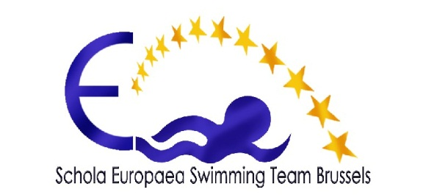 Brussels, the .............................................

Parental Autorisation

I/we the undersigned, ..................................................................................................................

resident ....................................................................................................................

authorise our child ..........................................................................................

student at the European School
Bruxelles I, av. du Vert Chasseur 46, 1180 Bruxelles
Bruxelles II, av. Jespers 75, 1200 Bruxelles
Bruxelles III, Bd du Triomphe 135, 1050 Bruxelles
Bruxelles IV, Drève Saint-Anne, 86, 1020 Bruxelles

To accompany the Swimming Team of the European Schools of Brussels during their travel, both in Belgium and abroad, for their competitions during the season 2014-2015.

Last & first name of the swimmer ……….........................................................................

Date of Birth .........................................................................................

Town & Country ………................................................................................

Nationality .........................................................................................

Passport or ID Card n° ..............................................
expires .............................

Brussels le ..............................................

Parent(s) Signature

