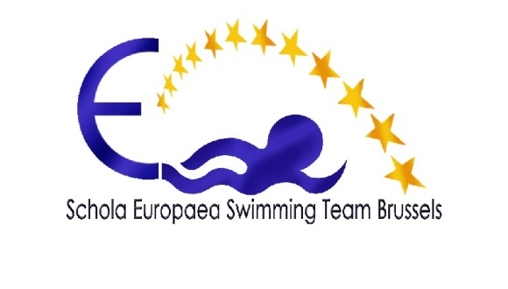
- CHARTER

1° Compétitions

- For one or two day competitions (not including Championship finals), the Team promises to post the information on its website ten (10) days before the competition.
Parents and/or swimmers will also be sent an invitation to swim via e-mail.

- Swimmers and/or their parents promise to inform the Head Coach as soon as possible (and before the deadline indicated) whether or not they are able to take part, by sending a message to the e-mail address given in the invitation to swim and on the website.
If there is any problem after the indicated deadline, the Head Coach must be informed.

ANY SWIMMER WHO FAILS TO TURN UP FOR A COMPETITION and does not justify his/her absence, or let the Head Coach know before the day of the competition, will receive the penalty of not being able to swim in the next competition.

2° Travel and swim camps

- The Team promises to ensure the best quality and price for all travel arrangements and swim camps.

- Parents promise to pay the cost of travel to competitions of more than 1 day, and swim camps, by the deadline indicated or at the latest, before any departure or camp; if there is non-payment, the Team cannot allow those swimmers, who are not up to date with the payments, to participate.

3° Subscription

- The Team receives no subsidies of any kind, therefore swimmers are asked to pay an annual subscription fee set by the Swim Team Committee. Payable immediately at the inscription of the swimmer.

- Parents promise to pay the subscription immediately on inscription of their swimmer(s); however, NEW swimmers may wait until after their second competition, should they decide to continue with the Team.

4° Team life

- The Team promises to look after its swimmers in the best way possible, always ensuring an adequate number (at least the legal requirement) of coaches and accompanying adults.

- Swimmers promise to :
  - follow the advice and instructions given by the coaches;
  - accept that the coaches’ decisions are final;
  - respect the Team spirit;
  - give a positive image of the Team;
  - demonstrate fair play and good sportsmanship;
  - abstain from alcohol and other harmful substances;
  - behave in a responsible manner;
  - take part in celebrations and events organised by the Team.

- Parents promise (as far as possible) to :
  - come and support their children;
  - accept that the coaches’ decisions are final;
  - offer help at competitions and events.

The Swim Team Committee

